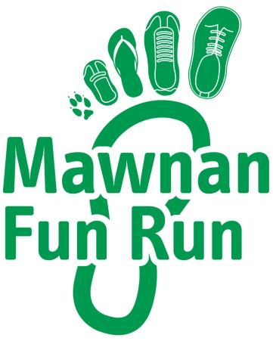  2017 |  |   FALMOUTH  ROTARY CLUB

MAWNAN FUN RUN YOUTH GRANTS
APPLICATION PROCEDURE & CRITERIA

Introduction

Mawnan Fun Run 2017 raised a grand total of £2,000 for Falmouth Rotary Club’s Charity Fund and in recognition of the fantastic support received from members of the village community the Club is donating up to 50% of this sum to youth organisations and charities within the Parish of Mawnan

The Fun Run Committee is now seeking applications for small grants which will benefit children and young people living within the Parish.

Criteria

- Applications will be welcomed from youth groups and organisations which primarily benefit children and young people under 18 years of age, who live within Mawnan Parish.
- The applicant should have a constitution/set of rules and must have its own bank account.
- The grant should be used to fund a specific trip, event, activity or piece of equipment. It should not be used as a contribution to the general running costs of the particular organisation.
- The grant should benefit the whole group/membership of the organisation, not a sole individual (except in the case of purchasing a special piece of equipment to enable the inclusion of a person/people with additional needs).
- Requests should be for a maximum of £250 and may fund up to 100% of the project costs. Match-funding is not a requirement, but if the request is for a contribution to a larger project you must show where the remaining funding will come from and whether it has already been secured.
- The grant should be spent by the end of December 2018.
- Applications will only be accepted on the attached application form and should be submitted to Mawnan Fun Run Committee, c/o Trenoon, Carwinion Road, Falmouth TR11 5JD or by email to rodallday34@gmail.com.
- Applications must be received no later than 28/02/18.

2017 |  | MAWNAN FUN RUN  Youth Grants Application Form |  | FALMOUTH  ROTARY CLUB
 | Organisation Name
 | Contact Name
Contact Address
(inc. postcode)
 | Phone Number
 | Email Address
 | Where & when does your group meet?
 | How many members/ users are there?
Project Description
(Summary of what the money will be used for, why you need it and how many children/young people will benefit)
Total Project Cost
(Please attach further details/ quotes)
Grant Requested
(max £250 - up to 100% of project costs)
Is match-funding available?
(If yes, how much and where will it come from? Has it already been secured)
Who should the grant be made payable to?
(your organisation will need its own bank account)

Applications should be submitted to the address/email shown below and
must be received no later than 28/02/18

